Introduction to Mathematical Finance
Problem Sheet 3 Answer

1. Which of the following is least likely a property of Student’s t-distribution?
A. As the degrees of freedom get larger, the t-distribution approaches the normal distribution. As the degrees of freedom fall, the peak of the t-distribution flattens and its tails get fatter (more probability in the tails—that’s why, all else the same, the critical t increases as the df decreases).
2. To apply the central limit theorem to the sampling distribution of the sample mean, the sample is usually considered to be large if n is greater than:
C. Sample sizes of 30 or greater are typically considered large.
3. The population’s mean is 30 and the mean of a sample of size 100 is 28.5. The variance of the sample is 25. The standard error of the sample mean is closest to:
C. 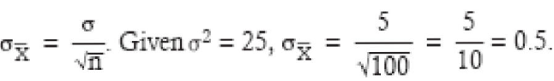
4. When constructing a confidence interval for the population mean of a nonnormal distribution when the population variance is unknown and the sample size is large (n > 30), an analyst may acceptably use:
A. When the sample size is large, and the central limit theorem can be relied on to assure a sampling distribution that is normal, either the t-statistic or the z-statistic is acceptable for constructing confidence intervals for the population mean. The t-statistic, however, will provide a more conservative range (wider) at a given level of significance.
5. An analyst who uses historical data that was not publicly available at the time period being studied will have a sample with:
A. The primary example of look-ahead bias is using year-end financial information in conjunction with market pricing data to compute ratios like the price/earnings (P/E). The E in the denominator is typically not available for 30–60 days after the end of the period. Hence, data that was available on the test date (P) is mixed with information that was not available (E). That is, the P is “ahead” of the E.
6. Which of the following three bonds (similar except for yield and maturity) has the least Macaulay duration? A bond with:
C Other things equal, Macaulay duration is less when yield is higher and when maturity is shorter. The bond with the highest yield and shortest maturity must have the lowest Macaulay duration.
A. Annual returns on small stocks have a population mean of 12% and a population standard deviation of 20%. If the returns are normally distributed, calculate a 90% confidence interval on mean returns over a 5-year period.
With a known population standard deviation of returns and a normally distributed population, we can use the z-distribution. The sample mean for a sample of five years will have a standard deviation of $\frac{20}{\sqrt{5} }=8.94\%$. A 90% confidence interval around the mean return of 12% is 12% ± 1.65(8.94%) = –2.75% to 26.75%.

B. A study was conducted by the British Department of Transportation to estimate urban travel time between locations in London, England. Data was collected for motorcycles and passenger cars. Simple linear regression was conducted using data sets for both types of vehicles, where Y = urban travel time in minutes and X = distance between locations in kilometers. The following results were obtained:
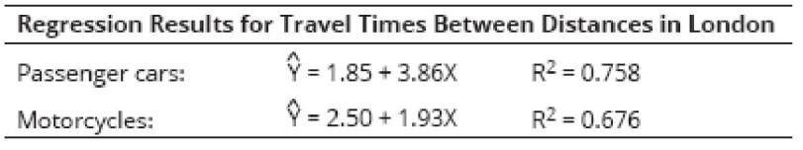
The estimated increase in travel time for a motorcycle commuter planning to move 8 km farther from his workplace in London is ?
Based on the regression results, which model is more reliable? Why?
The slope coefficient is 1.93, indicating that each additional kilometer increases travel time by 1.93 minutes: 1.93 × 8 = 15.44mins
The higher R² for the passenger car model indicates that regression results are more reliable. Distance is a better predictor of travel time for cars. Perhaps the aggressiveness of the driver is a bigger factor in travel time for motorcycles than it is for autos.

C. An analyst is interested in predicting annual sales for XYZ Company, a maker of paper products. The following table reports a regression of the annual sales for XYZ against paper product industry sales. The correlation between company and industry sales is 0.9757. The regression was based on five observations.
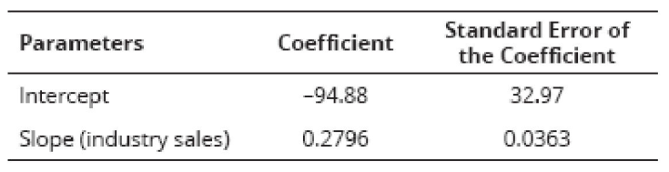
Calculate and interpret the R² of the regression.
Based on the regression results, how much is XYZ Company’s market share of any increase in industry sales expected to be?
The R² is computed as the correlation squared: (0.9757)² = 0.952
The interpretation of this R2 is that 95.2% of the variation in Company XYZ’s sales is explained by the variation in industry sales. The independent variable (industry sales) explains the variation in the dependent variable (company sales). This interpretation is based on the economic reasoning used in constructing the regression model.
The slope coefficient of 0.2796 indicates that a $1 million increase in industry sales will result in an increase in firm sales of approximately 28% of that amount ($279,600)

D. Assume a bond has an effective duration of 10.5 and a convexity of 97.3. Using both of these measures, estimate the percentage change in price for this bond, in response to a decline in yield of 200 basis points.
Total estimated price change = (duration effect + convexity effect)
{[–10.5 × (–0.02)] +[1⁄ 2 × 97.3 × (–0.02)²]} = 21.0% + 1.95% = 22.95%

